

SMARTER WORK MANAGEMENT SYSTEM

System Requirements Specification Document v 1.0

V.SundaraGopal
sundaven@in.ibm.com

Table of Contents:

Introduction 3
Scope: 3
Management Summary 3
System Objectives / Overview 4
Figure 1 System Context Diagram 5
Refrences 5
Initial requirement document 5
Common requirements: 6
Error & Exception Handling Requirements 6
Auditing/Logging Requirements 6
Functional Requirement 1 – Login Page 6
Brief Description 6
Interface Details 6
Requirement Details: 6
Validations: 7
JS validation: 7
Functional Requirement 2 – admin Module 7
Brief Description 7
Adding new user 7
Interface 7
Table of requirement 8
Functional Requirement 3 – Consultant Module 8
Brief Description 8
Interface 8
Table of requirement 8
Functional Requirement 4 – Lead Module 9
Brief Description 9
Interface 9
Table of requirement 9
Database Schema: 10
SQL Script for table creation: 10
Test Cases: 10
Unit Test Cases – SSMS 10
NFR – Test cases 11
Disclaimer 11
Products to be used: 11
Resource & References: 13

Introduction

Scope:

This document describes the scope of the requirements for the Smart Work Management System (SWMS) for ABC Corp. The document details all the high level requirements with intent to validate ABC’s requirements. This document should be used by the Architect and the developers to design the Solution Architecture for the project.
In addition to this, the document also describes the broad scope of the project
The scope of this project involves developing the SWMS which has three modules. – Consultant module whereby the consultants can enter their time against the actual for the project assigned by the lead, Lead module – where by the leads can assign the projects to respective consultants and also track the timings entered. The Administrator module - who define access of the Consultant/Lead. This application enables you to monitor the working patterns, time taken for completing a task and the skills of the Consultant. The lead also submits his opinion about the performance of the Consultant for the perusal of the admin. This is an effective in-house tool for performance analysis.
The project is to be deployed in the development environment of ABC corp.

Management Summary

For the past few years the attrition rate was increasing and it has touched its max in current Q4. The company board is much worried about the attrition and after analysis they came to know that the appraisal system what they have has some flaws which is also contributing to the attrition.
They are planning to come up with Smarter work management system(SWMS) which can take care of the following.

This application should have 3 modules – Consultant module whereby the consultants can enter their time against the actual for the project assigned by the lead, Lead module – where by the leads can assign the projects to respective consultants and also track the timings entered. The Administrator module - who define access of the Consultant/Lead. This application enables you to monitor the working patterns, time taken for completing a task and the skills of the Consultant. The lead also submits his opinion about the performance of the Consultant for the perusal of the admin. This is an effective in-house tool for performance analysis.

System Objectives / Overview

Consultant
Lead
Admin

SWMS

Figure 1 System Context Diagram

The diagram above explains the main conceptual elements in the solution and its
relationships with the architecture. The SWMS component helps in assigning and tracking work in a professional marketplace. The Lead has rights to assign task to the consultants under a lead and track the progress of the tasks assigned. The consultant can view the tasks assigned and accordingly enter the man hours in actuals against each tasks when the task gets completed and submit the same for lead approval. The lead can then review the time taken and quality of the work and submit his recommendation on the same. The admin has full right in the system. He can also add new user either as Lead/consultant and assign a consultant to a lead.
SWMS | Smarter Work management system which is going to be built. It has 3 modules viz. admin, consultant & lead
Admin/ consultant / lead | Based on the role, an user can log into their respective module and carryout the actions. A thin client UI has to be developed for login and SWMS should be accessible from anywhere thru web.

Refrences:

Initial requirement document –

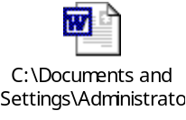

Common requirements:

Error & Exception Handling Requirements
All the program related errors should be captured and a UI friendly error message has to be thrown to the User who interacts with the application.

Auditing/Logging Requirements
Proper logging & Auditing has to be done for all the user who logs into the system. The logs are also needs to be maintained by orderting Viz.. info, debug, error, exception.

Functional Requirement 1 – Login Page

Brief Description
The login page is common for all the modules in the application. Based on their role, the user has to choose their role in the dropdown combo.

Interface Details

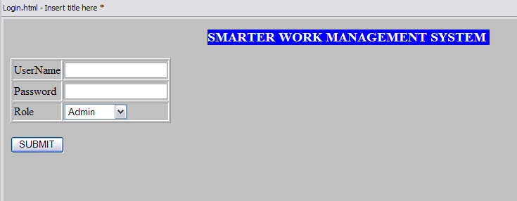

Requirement Details:
SI No | Field Name | Field value
1 | UserName | TextBox - The username of the user to login to the application
2 | Password | TextBox - The password of the user to login to the application
3 | Role | Dropdown box - The user has to select wheather he is and admin/consultant/lead from the drop down combo and then clik on submit to login.

Validations:
Once the user submits the login, the user credentials has to be validated in the DB and based on his role he should be diverted to his specific module.

JS validation:
Nil

Functional Requirement 2 – admin Module

Brief Description
The admin module takes care of assigning user as consultant/lead. He can also login as lead or as consultant.

Adding new user

Interface

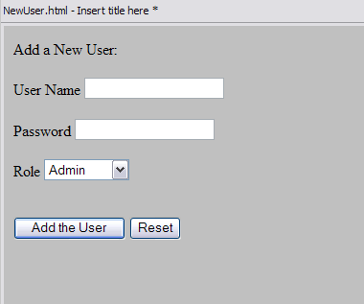

Table of requirement
Username | TextBox - The username for the new user to be created
Password | TextBox - The password for the new user to be created
Role | Dropdown combo box - the role of the new user to be created
Submit | Button - after filling the form and clicking submit button, submits the data to the DB and creates the new user
Reset | Button – clears the form

Functional Requirement 3 – Consultant Module

Brief Description
The consultant can login to the application and see the assigned tasks and enter man hours on each tasks completed and submit it.

Interface
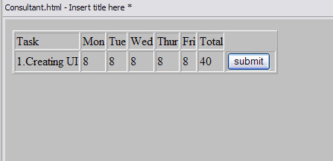

Table of requirement
Mon/Tue/Wed/Thur/Fri | TextBox - The consultant can enter the number of hours in the textbox down every day specifying the number of hours it took to finish a task
Total | AutoPopulating TextBox Non editable - Based on the number of hours entered from Monday to Friday the total hours text box should sum up the value and display it
Submit | Button – by clicking the submit button, the user submits his entry into the system.

Functional Requirement 4 – Lead Module

Brief Description
The lead module can review the timesheet of the consultant. He can also add his comments and submit it

Interface
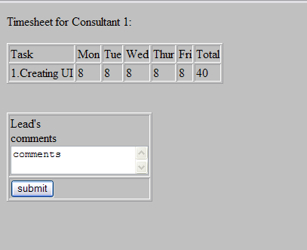

Table of requirement
Lead comments | Text Area - The lead can type in his comments regarding that particular’s timesheet review
Submit | Button – by clicking the submit button, the Lead submits his entry into the system.

Database Schema:

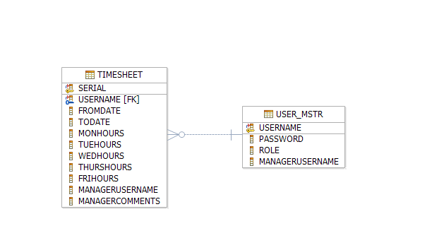

SQL Script for table creation:

This DB scrips were prepared against the derby DB for the above topology.

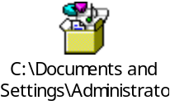

Test Cases:

Unit Test Cases – SSMS

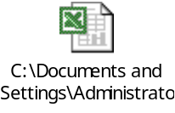

NFR – Test cases

Disclaimer

Most of the DB requirements are captured in the specification. But while developing the solution if the developer has a valid point to add more fields then it can be accommodated after consultation since the DB schema is not freezed as yet.

Products to be used:
Scenario | Product | Description
Developing Use case & UML related activites | IBM Rational Software Modeler, (RSM) | All the UML related specs needs to be developed using RSM only.
Development | IBM Rational Application Developer(RAD) OR WebSphere Integration Developer (WID) | The development of Java/J2EE artifacts should be on RAD or WID only
Database | IBM DB2 V 8.1 or higher | For all the DB requirements, the team should use IBM DB2 only
Team repository | IBM Rational ClearCase | The project team should share there artifacts between them using Rational ClearCase only.
Deployment – Java/J2EE solutions | IBM WebSphere Application Server ND V 6.1 (WAS) | The team should deploy their solutions for testing/production on WAS ND V6.1 only. They should be able to configure the server resources that are required for their solution.

Trademarks

- DB2, IBM, and WebSphere are trademarks or registered trademarks of IBM Corporation in the United States, other countries, or both.
- Windows and Windows NT are registered trademarks of Microsoft Corporation in the United States, other countries, or both.
- Java and all Java-based trademarks and logos are trademarks or registered trademarks of Sun Microsystems, Inc. in the United States, other countries, or both.
- Other company, product, and service names may be trademarks or service marks of others.

IBM copyright and trademark information: http://www.ibm.com/legal/copytrade.phtml
-----------------------------------------------------
Note: Regarding trademarks:

Trademarks Owner
---------- -----
UNIX The Open Group
Intel, Intel Inside logo, MMX, Pentium Intel
Java and Java-related terms Sun (Use ™ , not ® for Java)
Microsoft, Windows, Windows NT, Windows Logo Microsoft
Linux Linus Torvalds

Resource & References:
- WebSphere Application Server on DeveloperWorks- http://www.ibm.com/developerworks/websphere/zones/was/
- Rational Application Developer for WebSphere Software- http://www.ibm.com/developerworks/rational/products/rad/
- Rational Modeler- http://www.ibm.com/developerworks/rational/products/modeler/
- Rational ClearCase- http://www.ibm.com/developerworks/rational/products/clearcase/
- WebSphere Integration Developer- http://www.ibm.com/developerworks/websphere/zones/businessintegration/wps/wps.html
- IBM DB2- http://www.ibm.com/developerworks/data/products/db2/index.html?S_TACT=105AGX11&S_CMP=FP
- IBM RedBooks- http://www.redbooks.ibm.com/

